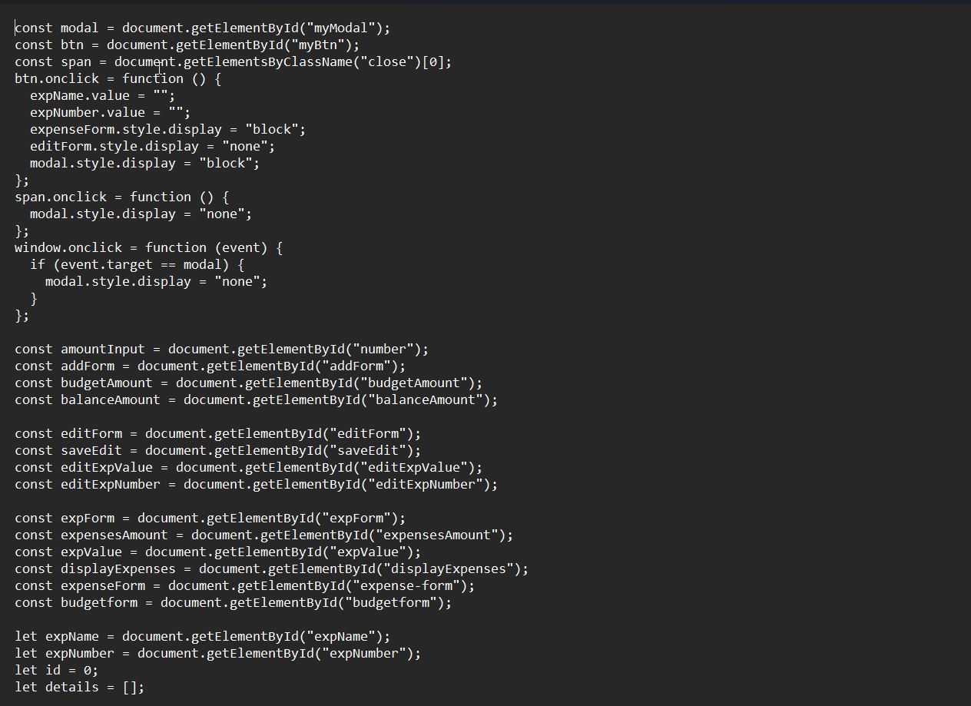

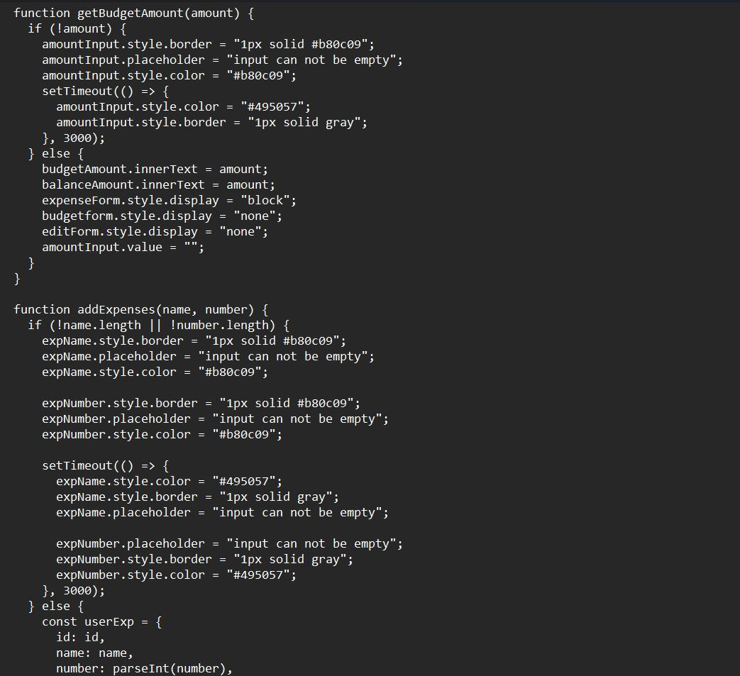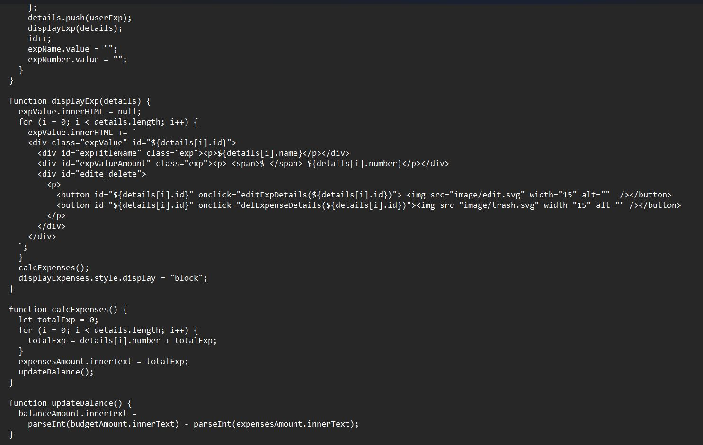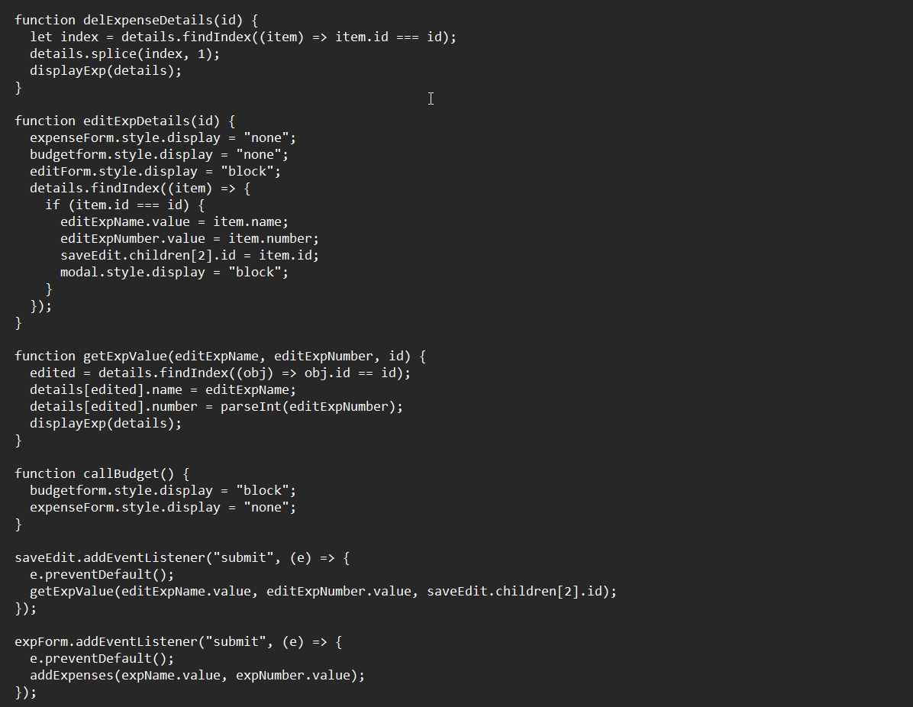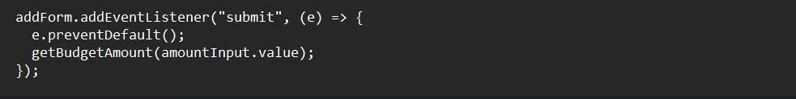@font-face {

font-family: "General";

src: url("./font/Nunito-ExtraLight.ttf");

}

@font-face {

font-family: "heading";

src: url("./font/Nunito-Bold.ttf");

}

body {

margin: 0;

padding: 0;

width: 100%;

font-family: "General";

height: 100vh;

background-color: #f5f5f5;

}

.container {

min-height: 80vh;

}

.header {

height: 60px;

width: 100%;

}

h1 {

margin: 0;

text-align: center;

font-family: "heading";

padding-top: 10px;

}

.budget-section {

display: flex;

justify-content: space-around;

align-items: flex-start;

width: 100%;

min-height: 160px;

font-weight: 900;

}

.budget-list {

display: flex;

justify-content: space-around;

align-items: flex-start;

width: 100%;

height: 70px;

font-size: 20px;

}

.exp-amount {

color: #b80c09;

}

.amount {

color: #317b22;

}

.col {

width: 40%;

text-align: center;

text-transform: capitalize;

}

.col p {

font-size: 40px;

padding-top: 5px;

margin: 0;

}

.toggle {

position: fixed;

right: 0;

bottom: 18px;

}

.toggle button {

border: none;

border-radius: 600px;

background: #04458f;

padding: 14px 20px;

color: #ffffff;

font-size: 30px;

margin: 10px 50px 0 0;

cursor: pointer;

}

/* modal form */

.budget-form {

width: 100%;

min-height: 200px;

}

form {

margin: 10px 0 20px 10px;

min-height: 100px;

}

input {

width: 60%;

padding: 8px 0;

border-radius: 6px;

border: 1px solid gray;

margin: 20px 0;

padding-left: 5px;

color: #495057;

}

.budget-list .exp p {

color: #b80c09;

font-size: 18px;

}

#displayExpenses {

width: 100%;

display: none;

}

.expValue {

display: flex;

justify-content: space-around;

height: 40px;

font-weight: 900;

text-align: center;

}

#expTitleName {

width: 40%;

}

#expValueAmount {

width: 40%;

}

#edite_delete {

width: 40%;

}

#edite_delete img {

cursor: pointer;

}

#edite_delete button {

margin-left: 1px;

background: none;

border: none;

}

.budget-form button {

background: rgb(1, 83, 1);

border: none;

border-radius: 6px;

color: #ffffff;

padding: 10px 40px;

cursor: pointer;

text-transform: capitalize;

font-size: 16px;

font-weight: 400;

}

#bug {

font-size: 14px;

background: none;

color: #04458f;

margin: 0px 0px 15px 10px;

text-align: justify;

padding: 0;

}

#expense-form {

width: 100%;

display: none;

}

#editForm {

display: none;

width: 100%;

}

#editForm button {

background: #b80c09;

border: none;

border-radius: 6px;

color: #ffffff;

padding: 10px 30px;

cursor: pointer;

text-transform: capitalize;

font-size: 16px;

font-weight: 400;

}

.expense-form button {

background: #b80c09;

border: none;

border-radius: 6px;

color: #ffffff;

padding: 10px 30px;

cursor: pointer;

text-transform: capitalize;

font-size: 16px;

font-weight: 400;

}

/* The Modal (background) */

.modal {

display: block;

position: fixed;

z-index: 1;

left: 0;

top: 0;

width: 100%;

height: 100%;

overflow: auto;

background-color: rgba(0, 0, 0, 0.4);

animation-name: fadeIn;

animation-duration: 0.4s;

text-transform: capitalize;

font-weight: 600;

}

/* Modal Content */

.modal-content {

position: fixed;

top: 20%;

left: 25%;

background-color: #fefefe;

width: 50%;

min-height: 40px;

animation-name: slideIn;

animation-duration: 0.4s;

}

/* The Close Button */

.close {

color: white;

float: right;

font-size: 28px;

font-weight: bold;

cursor: pointer;

color: #000;

}

.modal-header {

padding: 2px 16px;

border-bottom: 2px solid gray;

}

.modal-body {

padding: 2px 16px;

}

/* Add Animation */

@keyframes slideIn {

from {

top: -300px;

opacity: 0;

}

to {

top: 0;

opacity: 1;

}

}

@keyframes fadeIn {

from {

opacity: 0;

}

to {

opacity: 1;

}

}